ANNEXURE II
Application from an individual for a licence to Establish, Maintain and Work an Amateur Wireless Telegraph Station in India. (See rules 6 & 8)

1.Name:( In Capitals) ………………………………..………………………………………………………
(Last name) (First) (Middle)
2. Father's Name :
and Address

3. Address (Present) :

4. Address (Permanent) :
City/Town |  | District
State |  | PIN
Res. No.
Mobile No.
Personal Email

5. Date of Birth (DD/MM/YYYY) | Place of Birth | Nationality | Occupation
 |  | INDIAN

6. (a) Category of licence applied for | (b) Exact location of the Station  (Including name of City, Dist, State & PIN)
Restricted / General Grade

7. Do you hold Radiotelegraph Operator's Certificate? If yes, give particulars: Yes / No
Name of the certificate | Cert. No. | Date of Issue | Validity

8. Particulars of Amateur Station Operator's Examination:-
Name | Centre | Month of Examination
Restricted / General Grade

9. Particulars of apparatus to be used:
Apparatus used` | Manufacturer's Name | Type No. | Frequency Range | R.F. Power Output
Transmitter | To Be Homebrewed or purchased after getting Licence
Receiver
Frequency Measuring Device

10. If appeared in any of the Amateur Station Operator's Examination. Yes / No
(If yes, indicate the date of the examination)

DECLARATION

I hereby solemnly declare that the foregoing facts are true and correct and nothing is false therein and nothing material has been concealed there from. I also agree that in case any information given by me herein before is found false at a later date, the licence, if granted, will be cancelled.

I further solemnly give an undertaking that I will not either directly or indirectly divulge to any person, except when lawfully authorised or directed to do so, the purport of any message which I may transmit or receive by means of any wireless apparatus operated by me or which may come to my knowledge in connection with the operation of said apparatus.

I have carefully read and understood the rules contained in the Indian Wireless Telegraphs (Amateur Service) Rules, 1978 and undertake to abide by them and observe the conditions of the licence. The licensed station shall not be made accessible to any unauthorised person at any time.

Signature of witness |  | Signature of applicant
Name (in block letters) |  | Name (in Block letters):
Address: |  | Date :
Date : |  | Place :

APPENDIX III
NATIONALITY CERTIFICATE

Certified that I have known Shri / Smt / Kum ____________________________________ son/daughter of Shri ______________________________ for the last _______ years and that to the best of my knowledge and belief he/she bears a good moral character. He / She is of INDIAN nationality. He / She is not related to me.

Address : Signature:
Dated: Designation :
Office Seal
(Should not be only in local language)

Note- This certificate should be from one of the officers listed below :-
1. Gazetted officers of Central or State Governments.
2. Members of Parliament or State Legislatures.
3. Sub-Divisional Magistrate/Officer.
4. Tahsildars or Naib/Deputy Tehsildars Authorised to exercise magisterial powers.
5. Principal / Head Master / Head Mistress of the recognized institutions (School / College) if applicant is a Bonafide student of that institution.

Personal Particulars Form

THE FOLLOWING DETAILS MAY ALSO BE FURNISHED

(Four Copies of this page are to be submitted)

- Name in full ( in block letters) :

- Date of birth :

- Place of birth :

- Age :

- Height :

- Colour of eyes :

- Complexion :

- Colour of hair :

- Identification marks :

- Full address (in block letters) :

Pin:
- Occupation
(Major work or profession for
which you receive money)

- Nationality : Indian

- Father’s name and home address :
(Aliases if any)
Pin:
14. Particulars of previous applications
if any made by the applicant for the
issue of Amateur Licence :

15. Type of Licence applied for : Restricted Grade / General Grade

- Exact location of station :
(Full address in block letters)

Pin:

Date: (Signature of applicant)

Personal Particulars Form

THE FOLLOWING DETAILS MAY ALSO BE FURNISHED

(Four Copies of this page are to be submitted)

- Name in full ( in block letters) :

- Date of birth :

- Place of birth :

- Age :

- Height :

- Colour of eyes :

- Complexion :

- Colour of hair :

- Identification marks :

- Full address (in block letters) :

Pin:
- Occupation
(Major work or profession for
which you receive money)
- Nationality : Indian
- Father’s name and home address :
(Aliases if any)
Pin:
- Particulars of previous applications
if any made by the applicant for the
issue of Amateur Licence :

- Type of Licence applied for : Restricted Grade / General Grade

- Exact location of station :
(Full address in block letters)

Pin:

Date: (Signature of applicant)

Personal Particulars Form

THE FOLLOWING DETAILS MAY ALSO BE FURNISHED

(Four Copies of this page are to be submitted)

- Name in full ( in block letters) :

- Date of birth :

- Place of birth :

- Age :

- Height :

- Colour of eyes :

- Complexion :

- Colour of hair :

- Identification marks :

- Full address (in block letters) :

Pin:
- Occupation
(Major work or profession for
which you receive money)

12. Nationality : Indian

13.Father’s name and home address :
(Aliases if any)
Pin:
14. Particulars of previous applications
if any made by the applicant for the
issue of Amateur Licence :

15. Type of Licence applied for : Restricted Grade / General Grade

- Exact location of station :
(Full address in block letters)

Pin:

Date: (Signature of applicant)

Personal Particulars Form

THE FOLLOWING DETAILS MAY ALSO BE FURNISHED

(Four Copies of this page are to be submitted)

- Name in full ( in block letters) :

- Date of birth :

- Place of birth :

- Age :

- Height :

- Colour of eyes :

- Complexion :

- Colour of hair :

- Identification marks :

- Full address (in block letters) :

Pin:
- Occupation
(Major work or profession for
which you receive money)

12. Nationality : Indian

13. Father’s name and home address :
(Aliases if any)
Pin:
14. Particulars of previous applications
if any made by the applicant for the
issue of Amateur Licence :

15. Type of Licence applied for : Restricted Grade / General Grade

- Exact location of station :
(Full address in block letters)

Pin:

Date: (Signature of applicant)

ASOC EXAMINATION UNDERTAKING

(To be issued by Parent/Guardian of candidates aged between
12 to Less than18 years)

To:
Officer in Charge
Wireless Monitoring Station

From:

I …………………………………………, Parent / Guardian / Head of Institution of ……………………………………….. have no objection to his/her participation in Radio Amateur activities and experiments. I undertake responsibility ensuring there of.
Yours faithfully,
Place :

Date: Signature

Letter requesting exemption for Section A of Part I (Radio Theory & Practice)

To

Officer in Charge
Wireless Monitoring Station

From:

Date:

Dear Sir,

Sub: Exemption for Section A of Part 1 of ASOL exam – reg

I am submitting application for ASOL exam. As I have passed

…………………………………………………………………………………………

I request you to exempt me from Section A of Part I of ASOL exam.

Enclosed please find attested copy of my certificate.

Thanking you,

Yours faithfully,

_________________________________________________________

ENCLS: GAZATTED OFFICER ATTESTED MY CERTIFICATE

ANY HELP PLEASE CONTACT : 0944 74 34 822…VU2NSL…SUBU vu2nsl@gmail.com
Instructions to applicants | Application form description | Form Section / Particular to verify | Self verification  (✓)
ALL | Main Application | Filled First Name, Middle Name, Last Name correctly [ write name as per sslc book ]
ALL | Main Application | Date of birth column has been properly filled
ALL | Main Application | Filled exact location of station completely viz., your house address. Col: 2, 3, 4, 6b  ----------------------------------------------------------------  COL: 7 , 8 , 10 NO TO BE FILLED. | All same address only
ALL | Main Application | Have you signed the Declaration section and filled the place section
ALL | Main Application | a witness to sign , any person from your home or office
ALL | Nationality Proof | Nationality certificate from a Gazatted officer to be obtained  [ known column at least 5 years ] Name and seal of the office to be there.
ALL | Personal Particulars | Four copies to be filled [ in computer also ]
ALL | Personal Particulars | Address and all details same as in Application form in coloumn: 10, 13, 16 | Same address only
ALL | Personal Particulars | forms are to be signed | Col.14 NIL
ALL | DATE OF BIRTH  PROOF….[ xth certificate or SSLC / PASS PORT/ BIRTH CERTIFICATE COPY] | Attestation is by proper gazetted officier | 2 copies.  [you will require one copy when you get result]
ALL |  | Gazetted Officier /Notary seal is properly affixed
ALL |  | Gazetted officer Name, Designation, Dept is properly written by attester himself / is present in the seal used
ALL | Photos | 2 copies of Passport sized photo (3 X 4cm ) included
ALL | Photos | Both photos has my Name written in the back
ALL | Photos | Photos has been enclosed in a small transparent plastic cover
ALL | Self addressed Envelope | ADDRESS WITH PIN CODE [capital letters]
ALL | Self addressed Envelope | properly self addressed UNSTAMPED
ALL | Self addressed Envelope | It's size is 27 X 12 cm
ALL | Date column in all forms | All dates have been entered in DD/MM/YYYY format
For Minor applicants (Age between 12 - 19 | Parental consent form | Completely filled Parental consent form attached
For Minor applicants (Age between 12 - 19 | Parental consent form | Parental consent form is signed by parent
Radio Theory and Practice exemption | Part 1 Exemption certificate holders | attached BE/ME ECE degree certificate Attested by Gazatted Officer
ONLINE PORTAL |  | SEE ATTACHED FILES FOR ON LINE PAYMENT OR EXAM FEE RS.100 | SEE ATTACHED FILE
 | PAYMENT

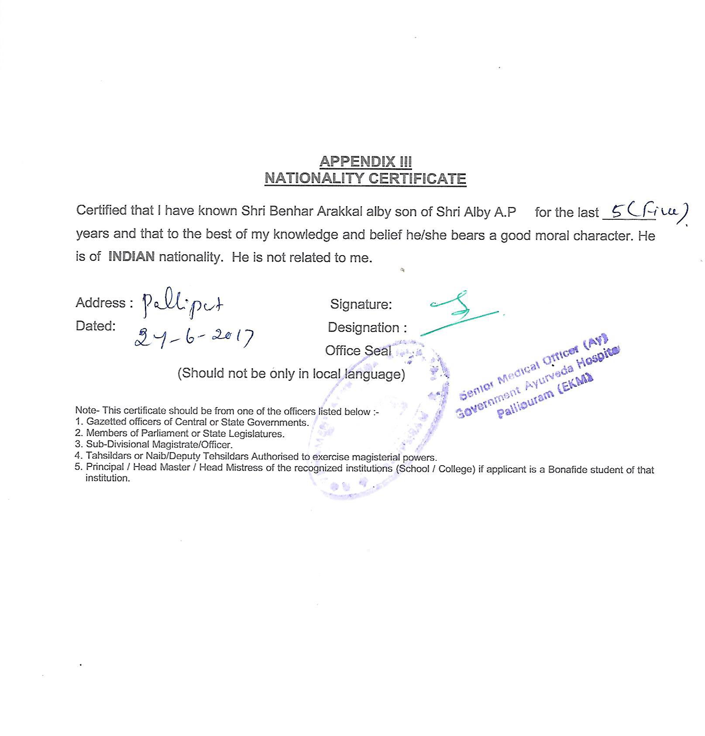
NATIONALITY CERTIFICATES - FROM KERALA GOVERNMENT VETENARY HOSPITAL DOCTOR,
DIRECTOR OF KRISHI BHAVAN, KERALA GOVERNMENT , AYURVEDA HOSPITAL, OR GOVERNMENT SCHOOL, ETC.,
NAME OF THE SIGNING AUTHORITY TO BE MENTIONED. OFFICE SEAL ALSO

FROM: DATE:
…………………………………………………………………. BY SPEED POST ONLY

………………………………………………………………….

……………………………………………………………………

From:………………………………………. BY SPEED POST
………………………………………………
………………………………………………..
……………………………………………..
……………………………………………….. date :…………….

TO
The Officer In Charge
Wireless Monitoring Station
Govt. of India MINISTRY OF COMMUNICTION, & IT, DOT’’
------------------------------------------------------

Dear sir,

My application for ASOC examination RESTRICTED GRADE.

I submit herewith my application for the ASOC RESTRICTED GRADE
EXAMINATION, with the all attachments.
1. ON LINE PORTAL PAYMENT DETAILS .RERNO………………………….DATED………………………………...FOR RS.100
2. DATE OF BITH PROOF DULY ATTESTED.
3. NATIONALITY CERTIFICTE .
4. TWO PASS PORT SIZE PHOTO IN PLASTIC COVER (NAME WRITTEN IN BACKSIDE IN CAPITAL LETTERS)
5. SELF ADDRESSED COVER (27X12 SIZE)(correct address to be written in center of cover with PINCODE)
I request you to include my application while conducting ASOC EXAM in any center .

Yours faithfully,
SIGNATURE
NAME:-----------------------------------------------------------------------
TEL NO:--------------------------------------- EMAIL.ID………………………………………………………..

Encls: On line Portal Receipt
Application, Nationality Certificate, DOB proof Attested, Two Pass port size photos/

